Week 8 Practical 8
Topics :
- Conditional formatting
- Inserting charts
- Sorting and filtering
- Advanced filtering
- Lookup functions

Q1. Following table contains the results of student. Highlight the marks which is greater than 50.
Student_No | Marks
St001 | 67
St002 | 45
St003 | 87
St004 | 90
St005 | 43
Q2. Copy above table to another location
- Select the range marks
- On the Home tab, in the Styles group, click Conditional Formatting, Manage rule
- Click Edit rule.
- Select rule type as Format all cell based on their values
- Change format style to 3-color scale. Then selected range color arranged according to the cell values.
Q3. Create column chart using above table.
Q4. Sort the mark sheet according to the descending order.

Q5. Create following table in your excel sheet.
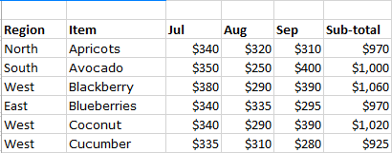
- Find the items that sub-totals are greater than $1000.
- Find the items where region is ‘West’ and sub-total less than $1000.
- Find the items where region is ‘West’ or sub-total less than $1000.
- Find the all items that sub-total between $950 and $1025.
- Find the all items with sub-total is greater than the average sub-total.

Q6. Insert following table to your excel sheet
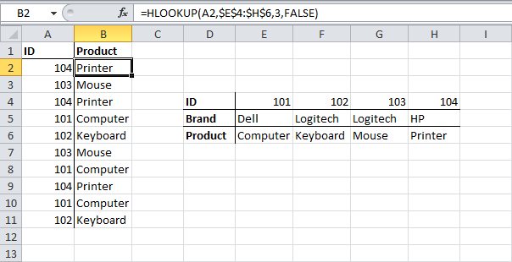
- Create another table using ID and Product and write vlookup function to find product when user insert the ID.

